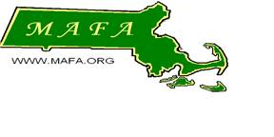Massachusetts Agricultural

Fairs Association

PO BOX 704

Chicopee MA 01021-0704

Email: secretary@mafa.org

**2023 MAFA State Photography Competition**

The Massachusetts Agricultural Fair Association (MAFA) is hosting a statewide photography contest this year. The first-place winner from each member Fair will be judged at the Annual MAFA convention on November 10 & 11, 2023. The winning photographs will be featured in one or more MAFA and Massachusetts Department of Agricultural Resources (MDAR) publications. The winning photographers will receive special recognition and passes to many Massachusetts Fairs.

**Contest Rules and Regulations**

* The photograph must be exhibited in a MAFA member’s 2023 Fair by a non-professional adult and/or youth exhibitor.
* The subject of the photograph must be agricultural in nature and/or depicting the agricultural aspects of a Massachusetts Fair.
* The photograph must be exhibited and judged to be the best overall photograph that meets the subject criteria for this contest at the originating member Fair.
* Though photographs may be exhibited at the Fair in a certain size, frame, etc., only an 8 x 10 inch unmatted and unframed photograph will be judged at the convention. Therefore, winning photographers may need to resize and/or de-frame and de-matt the original exhibited piece before it is submitted to MAFA.
* The winning photograph will reproduce with the best quality if it is taken with a minimum of 300 dpi, but this is not a requirement for submission.
* MAFA and MDAR have the right to use the winning photograph in publications promoting agriculture in the state of Massachusetts.